This post was published to Code Blog at 9:04:00 AM 1/31/2017

Azure Active Directory B2C With Angular2 and ASP.Net Web API

# Consuming a B2C secured Web API from an Angular2 Web App.

## Setting up the B2C Tenant

This post will use a test b2c tenant.

If you need to create a B2C tenant, follow [these steps.](https://docs.microsoft.com/en-us/azure/active-directory-b2c/active-directory-b2c-get-started)

In the azure portal, existing B2C tenant settings can be found by searching for 'Azure B2C'.

We're interested in the 'Sign-up or sign-in policies'.

If there are no policies listed, Add a new default policy.

This policy allows a user to sign in/register with a verified email address.

### Setup a new application

Save the Application ID for later.

Make sure the Reply URL ports correspond with your development environment.

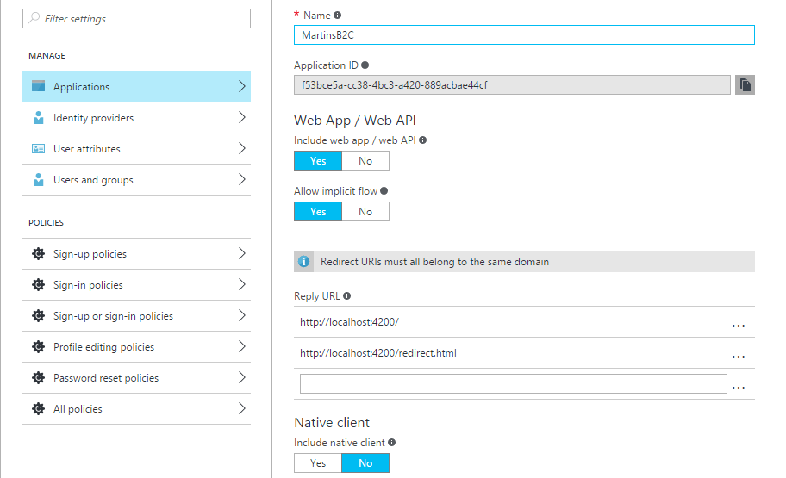

## Setting up the Angular2 Front-End

//TODO

## 

## Setting up the .NET API Back-End

//TODO